Leading Better Care 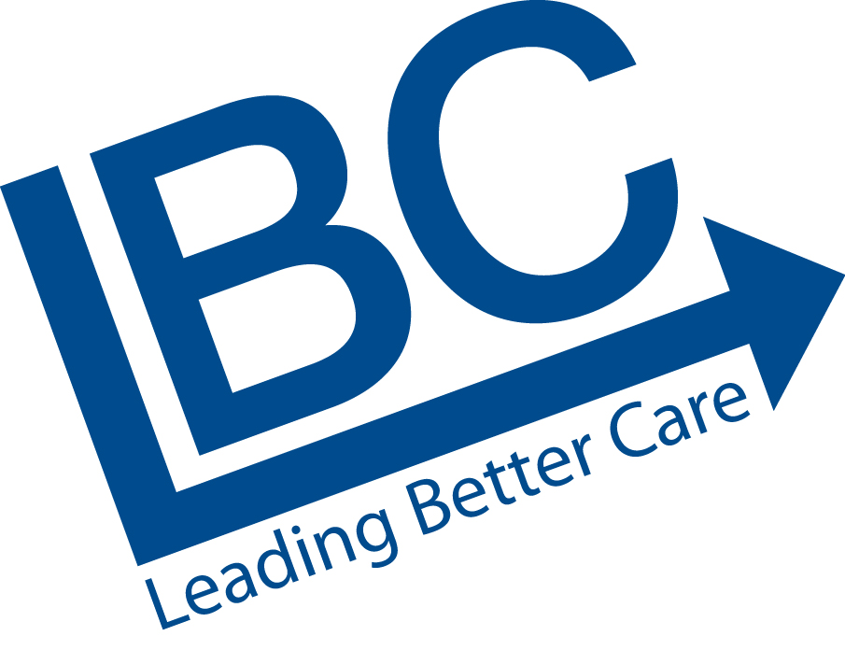
Sharing Good Practice

NHS Board: NHS Borders
Ward: Ward 16 (Gynaecology)

Details of Improvement:

What was the particular problem that this case study is about?
Exploring moving from a traditional in-patient Hysteroscopy service to an outpatient Hysteroscopy clinic to further enhance person centred, clinically effective, safe patient care.

How was this identified?
Benchmarking with other Health Boards, visiting abnormal bleeding clinic in Hexham and performing a literature review identified evolving pockets of good practice and the procedure being performed with and without local anaesthetic on a day case basis.

What were the implemented improvements (what tools/techniques did you use)?
Application of workload / workforce planning tools and development of a specific Integrated Care Pathway.

What is the situation now?
Patients requiring Hysteroscopy attend the ward for a 20 minute Out-patient appointment. This has increased capacity from 2 theatre sessions per month (equating to 2 patients) to 4 ward based sessions every 2 weeks (equating to 8 patients).

How is the change sustainable?
This clinic is fully funded, deemed routine, good practice and is a valued service for Patients and Staff.

Measurable outcomes

What are the patient benefits?
- Care delivered in an ambulatory setting
- Leads to prompt diagnosis of gynaecological abnormalities and cancers
- No general anaesthetic reducing risk
- Promote self control to maintain dignity
- Beneficial to all aspects of Patient recovery (maximum stay 45 mins)

Patient Pilot Questionnaire results identified:-

 | Yes | Partly | No
Did you feel the Staff offered adequate support to you? | 21 | - | -
Did you experience any discomfort? | 7 | 8 | 4
Would you have preferred to wear a hospital gown? | - | - | 21
Did the information sheet you received with your appointment explain the procedure adequately? | 19 | - | 2

Patients have additionally described the following benefits:-
- Advantages with not having a general anaesthetic means minimal support is required from relatives post procedure
- Less time off work
- Minimal childcare requirements

What are the staff benefits?
- Outpatient clinic on the ward does not affect Bed capacity and impact on elective admissions
- Review of workload / workforce planning identified clinic nursing tasks could be performed by a Band 2 HCSW, supported by the trained staff on the ward

What are the organisational benefits?
- Improve patient experience, person-centred care
- Reduced Length of Stay
- Increased Hysteroscopy capacity
- Theatre time released for another Speciality to utilise
- Costs Savings

Annual Staffing costs based on 4 hour clinic per week for 52 weeks:

1 x Band 2 Nurse = £1,895.00
1 x Band 5 Nurse = £3,680.00

Total In-patients costs = £30,829.52
Total Out-patient costs = £ 5,575.00 + Consultant 4 hours
Bed Costs £ 0

Savings £25,254.52 + Consultant 4 hours

Equipment: 4 x Hysterscopes = approx £17,000.00 (one off cost)
4 x cages to protect scopes = £1,400.00 (one off cost)
1 years supply Versascope sheaths = £2,488.30

How did staff feel before the improvement/during the improvement and after the improvement?

Before: Its ‘aye been’ – part of the workload – why do we need to look at this?
During: Motivated – attempting to improve Patient Experience, but – How will it affect Staffing
levels? Will there be enough Patients on the lists to keep us in our jobs?
After: Proactive quality initiative / Less anaesthetic problems / Better for Patients / Supporting
develop HCSW – meeting PDP

What are the lessons learnt and what would you do differently next time?
Reinforced the importance of Staff involvement in robust benchmarking, education and service progression to alleviate anxiety and attain ownership and pride in testing a new process to enhance service provision

What plans are there to spread the improvement?
Active discussion re other potential services that could be transformed to out-patient clinics

Contact information for case study

Anne Simpson
Senior Charge Nurse
Ward 16
ann.simpson@borders.scot.nhs.uk Tel: 01896 26016

